**PURPOSE:**

To provide an electronic means for employees to volunteer for overtime and for Supervisors to select volunteers for assignment in order to eliminate human error and wasted time dealing with hand-written solicitation sheets (Fig. 1).

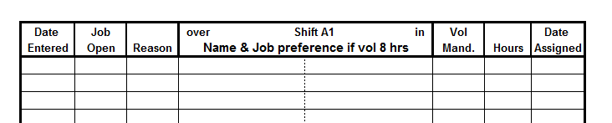

Fig. 1

**SCOPE:**

Develop a program that is preferably accessible from multiple points of use (such as an employee kiosk and a Supervisor’s desktop) that has different levels of authority based on the identity of the individual that is logged in. The program needs to meet the following criteria based on whether an hourly employee or salaried Supervisor is logged into the system:

***Requirements for Hourly Employee (EE) Interface:***

* EE must be able to self-identify @ interface by scanning their badge barcode.
* All EE logins will be time-stamped for retention and traceability.
* EE’s will have the ability to select a date that is between (2) and (14) days [48-336 hours] from their login time (Fig. 2).

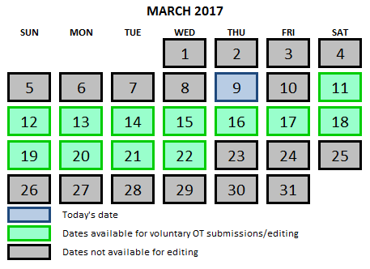

Fig. 2

* EE will then have the ability to select a shift (1, 2, 3) within the selected date.
* EE will then have the ability to select a job code within the selected shift. Job codes will be displayed via a drop-down list (or equivalent) that allows EE to select from ALL job codes within the plant (Fig. 3).

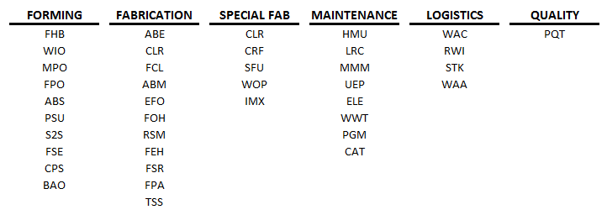

Fig. 3

* Once a shift and job code have been selected, the EE will have the ability to see any “OT Needs” that have been created for that criteria by the Supervisor AND any OT submission that have already been entered by other EE’s, if any exist.
  + A button stating “BUMP” needs to be located next to each EE submission so the active user has the ability to bump them from their OT slot if feasible (Fig. 4).  *EE’s on off-going shifts have preference over EE’s on oncoming shifts. Therefore, EE’s on off-going shifts have the ability to BUMP EE’s that have already signed up for OT from oncoming shifts.*

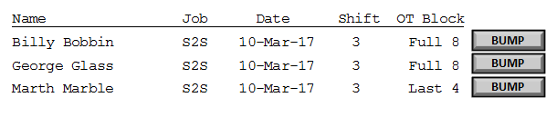

Fig. 4

* Regardless of whether a need has been posted or not, the EE will have the ability to submit themselves for voluntary OT.
* EE will then have the ability to select an overtime block for the selected job code and shift:
  + First 4 Hours of Shift
  + Last 4 Hours of Shift
  + Full 8 Hour Shift
* Once an EE has finished the selection criteria for submitting themselves for voluntary OT, a free-form “Comments” field with a 20 character limit needs to be made available to them to define their preferred work area (i.e., Relief, 5C, etc.)
* Figure 5 illustrates the stratification of the selection process outlined above:

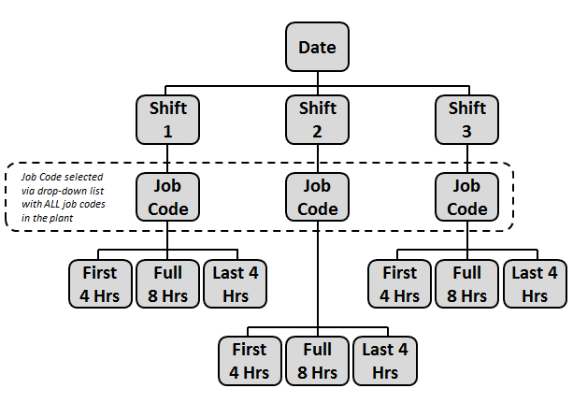

Fig. 5

* EE will “confirm” selection when complete to save and exit the program.
* EE’s will have the option to EDIT a previously saved submission as long as the submission being edited is still within the (2) to (14) day time window.
* Sessions will time out after 30 seconds of inactivity.
* EE’s will only have the option of creating or editing (1) OT submission per login with their ID badge.
* EE’s will have access to a screen that shows the names of all employees that have entered voluntary OT submissions (by job code) for any given shift, including which OT submissions have been assigned or declined by the Supervisors.

***Requirements for Salaried Supervisor (SS) Interface:***

* The navigation of the program by the SS is in the same structure as shown in the EE Interface section of this document.
* SS will have the ability to login to the program via the EE kiosk by scanning his/her badge or via their desktop.
* SS has the ability to generate an “OT Need” for any given, shift, job code, and OT block that is visible to EE’s that login to the system when volunteering for OT. The OT Need can be for multiple quantities within the same job code and shift.
* SS has the ability to “Assign” or “Decline” any voluntary OT submissions by the EE’s for any given shift by clicking a button or checking a box on the computer.
* SS has the ability to print a simple report showing the OT assignments for any given shift based on EE OT submissions that have been “Assigned” and not “Declined”.
  + The report will also indicate when an EE has been bumped by another EE.
  + The report will also show any comments entered by the EE, indicating where the preferred work area is located.

The program must have an auto-save and back-up feature so that data is not lost in the event of a power outage.

**Author:** Justin Munn

**FFU Team:** Guy Hoffman, Jeff Allen, Adam Davis, Steve Truesdell, Robert Frazier, Darren Plunkett, Justin Munn

**Submission Date:** 3/9/2017